
NAME: SAMUEL NJUGUNA.
ADM NUMBER: BSCCS/2024/54633.
BACHELOR OF SCIENCE IN COMPUTER SCIENCE, SEP 2024 INTAKE.
UNIT CODE: BIT3208.
LECTURER: MR. MICHAEL NYORO.
YEAR III, SEM II.

PROJECT DETAILS.
NAME: PITSTOP PARTS.
TECHNOLOGIES SELECTED;
- Frontend.
- HTML5 for page structure and semantics
- CSS3 for all custom styling, animations, and transitions
- Bootstrap 5.3 for the responsive grid system and layout breakpoints
- Vanilla JavaScript for interactivity
- Backend
- PHP 8 for all server-side logic, form handling, session management, and routing.
- Database
- MySQL running through XAMPP on localhost.

TABLE OF CONTENTS.
Week 1: Local Environment Setup
Installation and Testing of Local Development Environment ................ 4
Reflections for Week 1 ............................................................................ 6
Week 2: Wireframes and GUI Design
User Interface Planning and System Design…………………................ 7
Reflections for Week 2 ............................................................................10
Week 3: JavaScript and PHP Basics
Frontend Interaction and Backend Foundations ......................................10
Reflections for Week 3 .............................................................................12
Week 4: Server-Side Components and Backend Development
Reflections for Week 4 ............................................................................14
Week 5: Database Components and CRUD Operations
Reflections for Week 5 .............................................................................16

WEEK ONE: LOCAL ENVIRONMENT SETUP.
Installation and Testing of Local Development Environment.
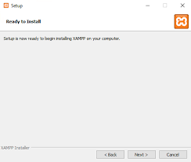
Fig 1: XAMPP Installation.
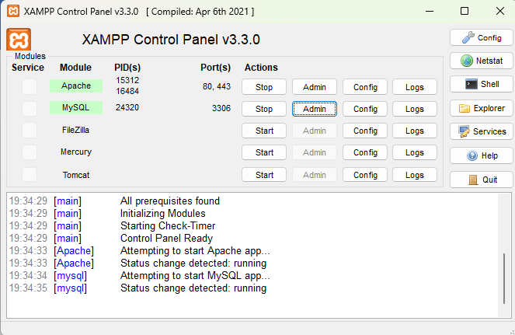
Fig 2: Apache and MySQL Running.
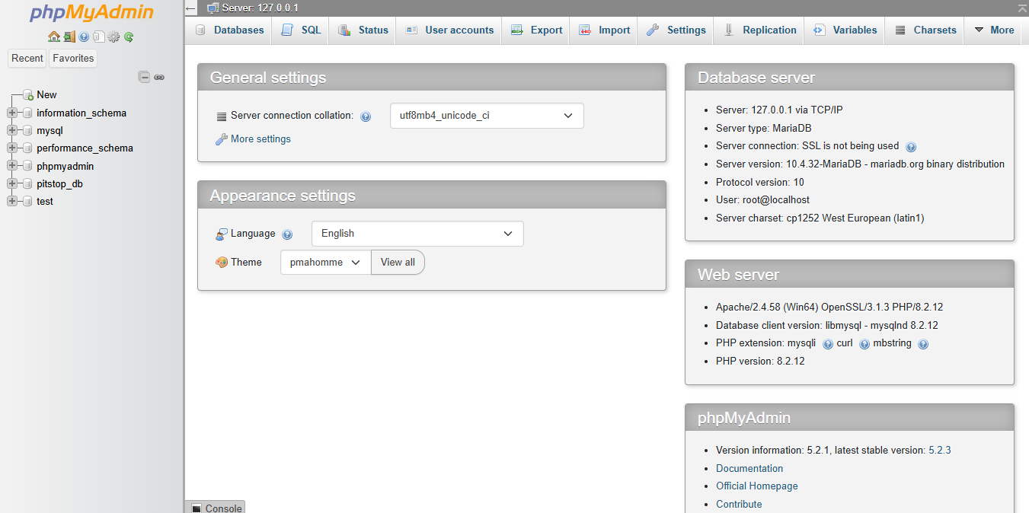
Fig 3: XAMPP Dashboard Page.
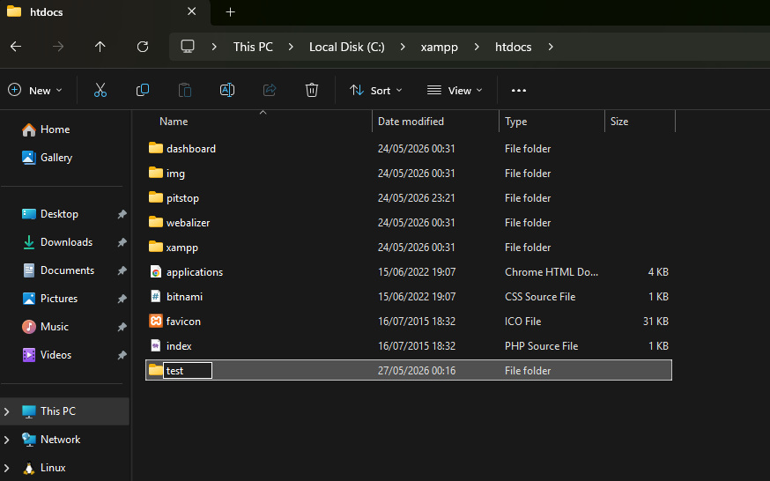
Fig 4: Test folder inside XAMPP htdocs folder.

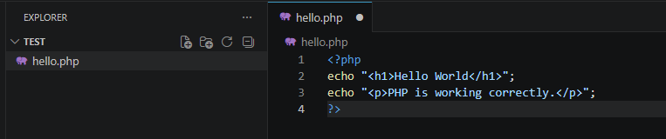
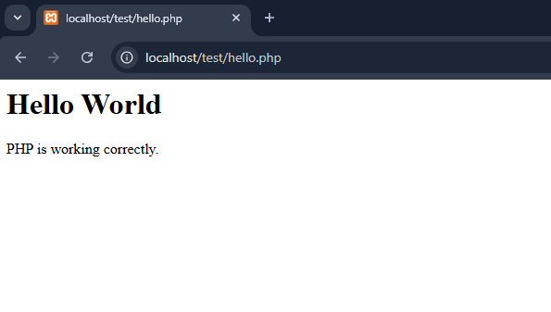
Fig 5: First PHP Page.
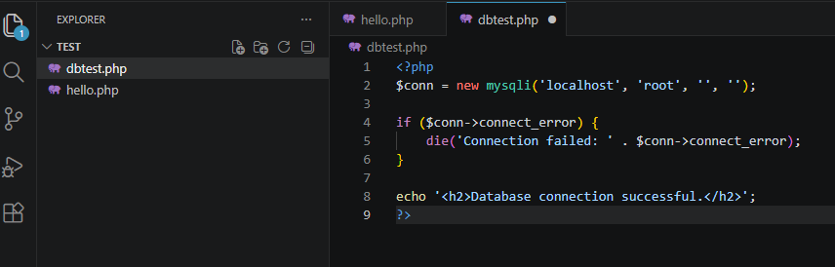
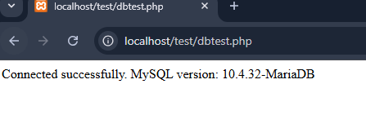
Fig 6: Successful Database Connection.

MY REFLECTIONS FOR WEEK ONE.
Lessons learned;
I learned how to configure a local development environment using XAMPP and how Apache serves PHP files strictly from the htdocs directory.
Technologies used;
I used XAMPP, Apache, MySQL, PHP 8.2.12, and VS Code as my code editor.
Challenges encountered;
My project folder was initially placed inside C:\xampp instead of C:\xampp\htdocs, which caused PHP files to render as blank white pages. I also discovered that plain HTML renders correctly while PHP requires the Apache module to be properly serving from htdocs.
Screenshots;
Fig 1 – Successful XAMPP Installation.
Fig 2 – Apache and MySQL running.
Fig 3 – XAMPP Dashboard running on http://localhost/
Fig 4&5 – Test page file inside XAMPP htdocs folder and first successful PHP page.
Fig 6 – Successful database connection.

WEEK 2: WIREFRAMES AND GUI DESIGN.
User Interface Planning and System Design.
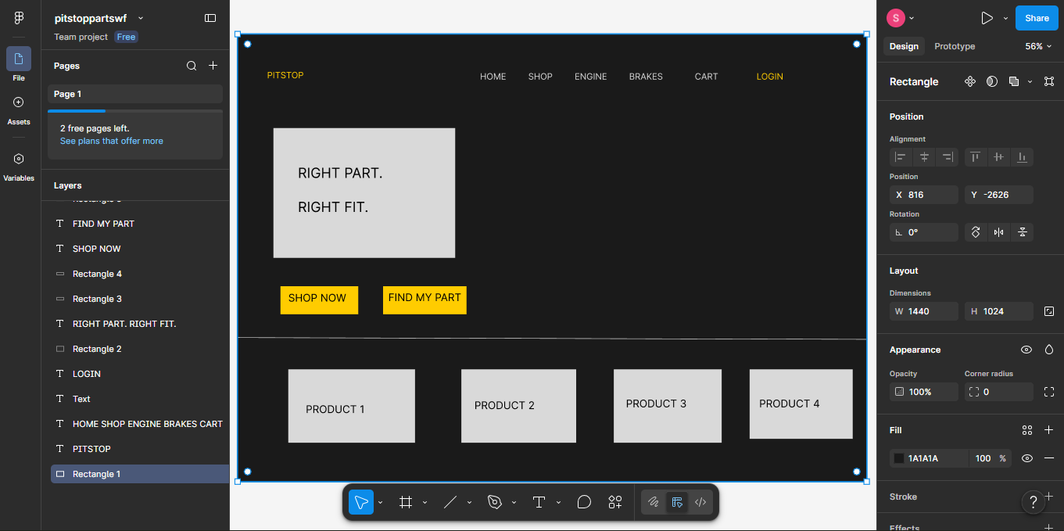
Fig 1: Landing page prototype designed in Figma.com.

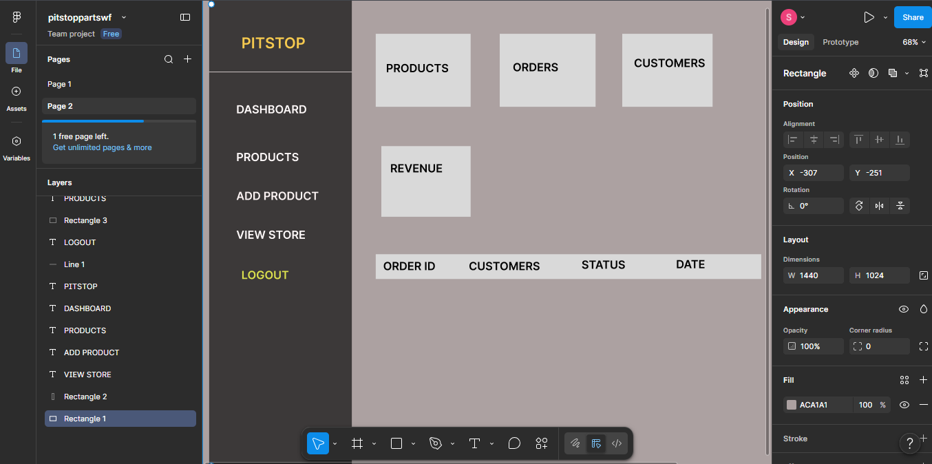
Fig 2: Admin page wireframe.
,  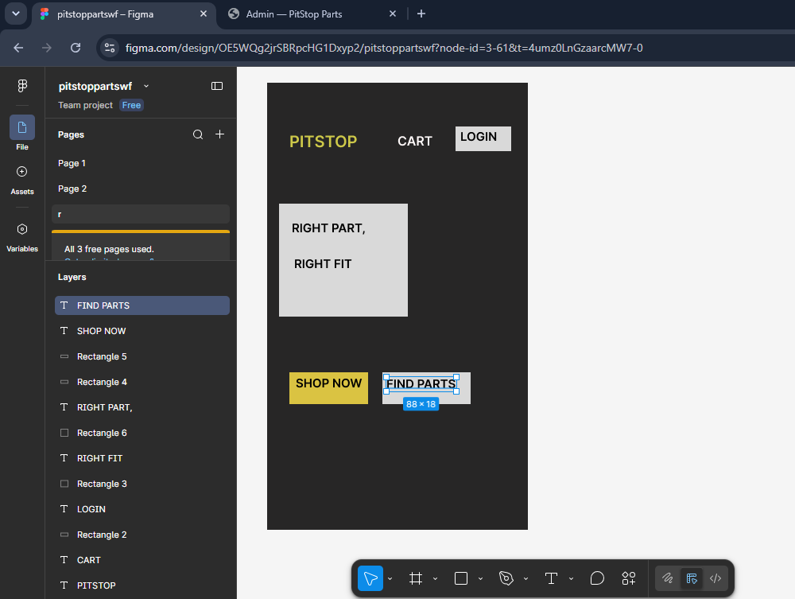
Fig 3: Mobile view mock up, showing mobile compatibility.
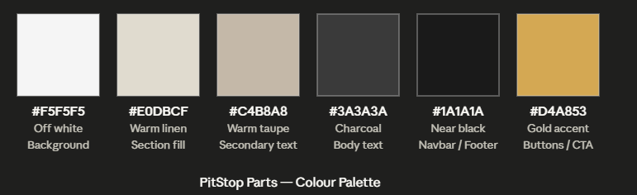

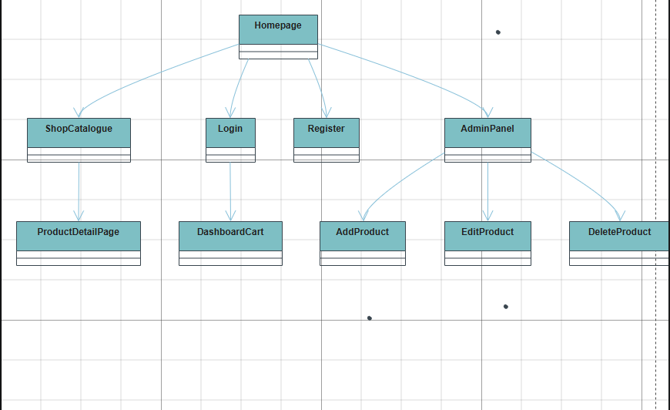
Fig 4: Color Scheme and simple navigation structure.

Fig 5: Actual landing page.


MY REFLECTION ON WEEK 2;
The design was selected to be eye-catching for the user, especially the gold accents. This will be enhanced by the changing hero background images to be incorporated.
The goal was to enabled the customer to be able to arrive at checkout after 4 actions, making the process quicker.
Intended system users are logged in customers, guests (They can still view store then login in to shop) and admin who is in charge of all CRUD operations.

Week 2 screenshots;
Fig 1 – Figma designed wireframe showing the navbar, Shop Now and Find Part buttons.
Fig 2 – Admin page wireframe layout.
Fig 3 – Mobile view mockup demonstrating responsive compatibility.
Fig 4 – Color scheme and navigation structure planning.
Fig 5 –Actual landing page.

WEEK 3: JAVASCRIPT AND PHP BASICS.
Frontend Interaction and Backend Foundations.
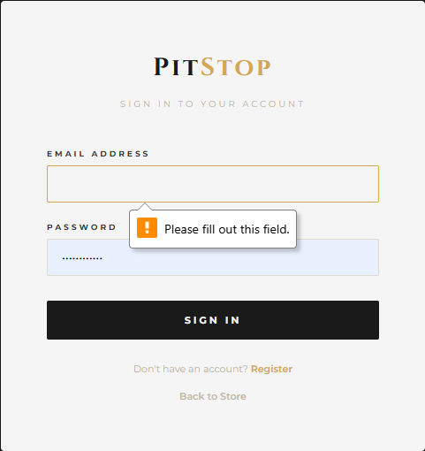
Fig 1: Failed login due to missing credentials, demonstrating proper form validation by
JavaScript.
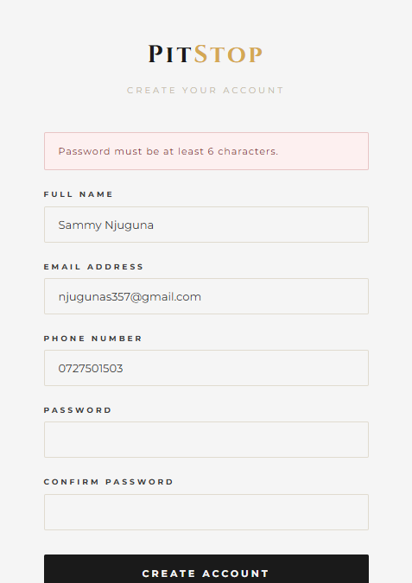

Fig 2: Password strength checker, indicating that password must be 6 characters or longer.

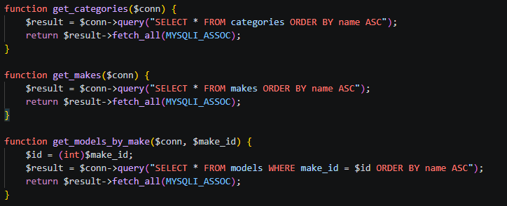
Fig 3: Snippet from functions.php. These demonstrate PHP syntax including functions, parameters, return values, and SQL queries.
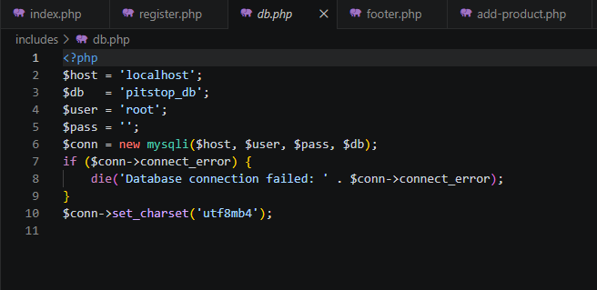
Fig 4: Screenshot showing the mysqli connection using localhost, root, and the database name.
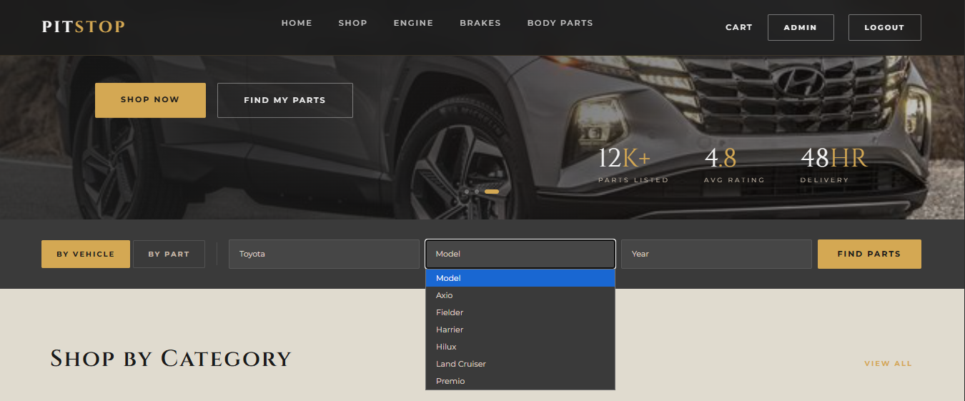
Fig 5: Dynamic model dropdown on the homepage populated via a JavaScript fetch request to get-models.php, which queries the MySQL models table and returns JSON data based on the selected vehicle make. Toyota returns corresponding Toyota models.

MY WEEK THREE REFLECTIONS.
Technologies used: JavaScript for form validation and dynamic dropdowns, PHP for backend functions and database queries, MySQL for storing and retrieving vehicle and product data, and the Fetch API for AJAX communication between the frontend and backend.
JavaScript running in the browser sends requests to PHP files on the server. PHP processes those requests, queries MySQL, and returns data which JavaScript then uses to update the page.
Why database connection matters Without the mysqli connection in db.php no page in PitStop can display products, validate login credentials, or process orders.

Week 3 screenshots;
Fig 1 – Failed login attempt demonstrating JavaScript form validation.
Fig 2 – Password strength checker enforcing a minimum of 10 characters.
Fig 3 – Snippet from functions.php showing PHP functions, parameters, return values, and SQL queries.
Fig 4 – mysqli database connection using localhost, root, and the database name.
Fig 5 – Dynamic model dropdown on the homepage populated via a JavaScript Fetch request to get-models.php, returning JSON data based on selected vehicle make.

WEEK 4: SERVER-SIDE COMPONENTS AND BACKEND DEVELOPMENT.

Fig 1: Screenshot of the PHP section that handles the POST request. This demonstrates PHP receiving and processing form data from the browser.
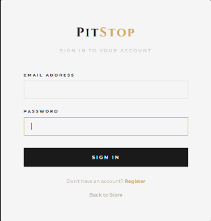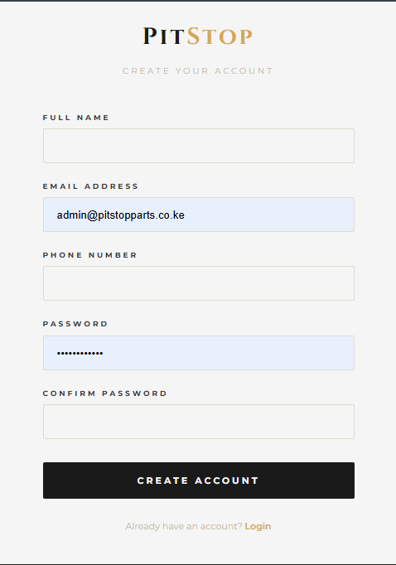
Fig 2: HTML forms using the POST method to send data to the server.
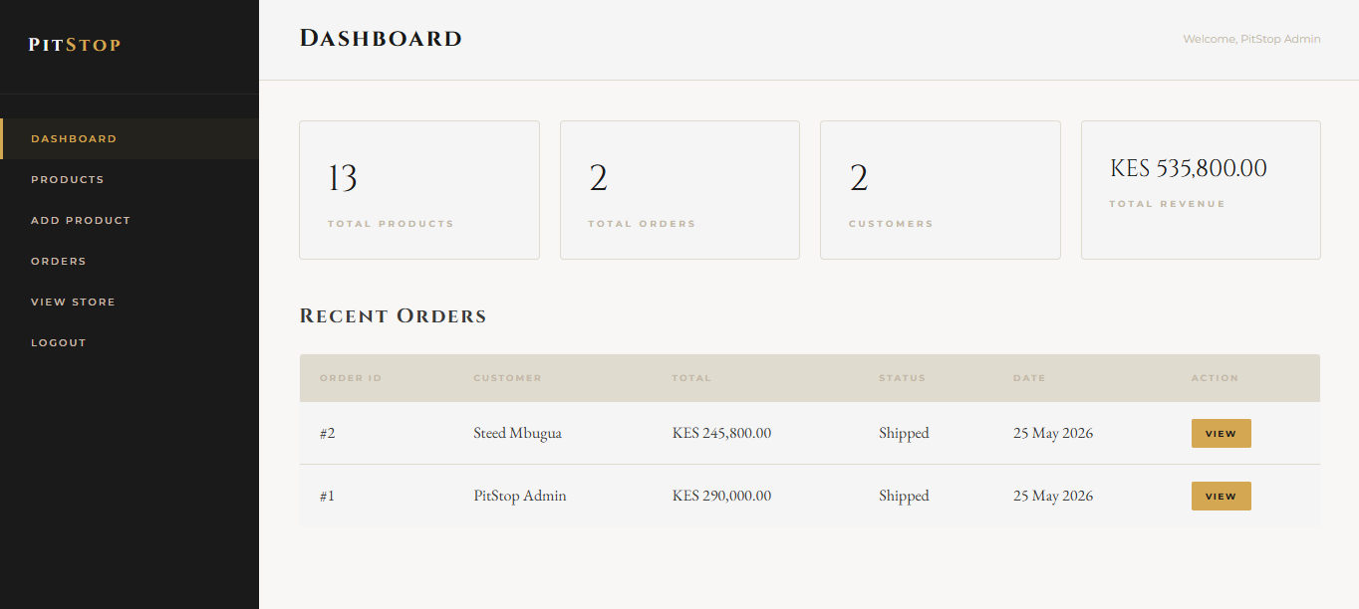
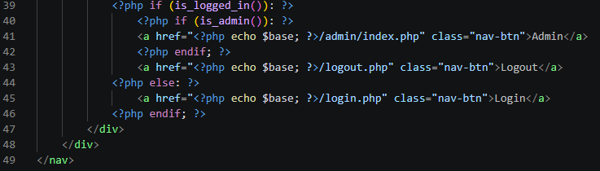
Fig 3: Session-Based Authentication, admin logged in. This demonstrates session-based authentication. PHP stored user ID and role in $_SESSION after verifying the password.
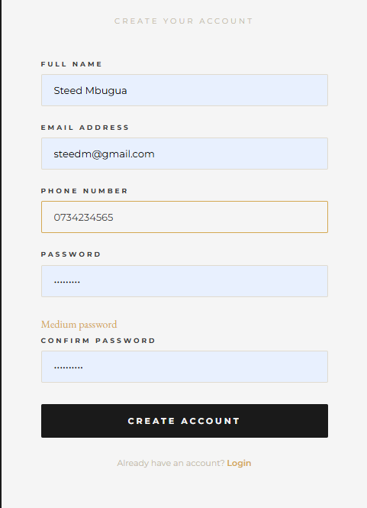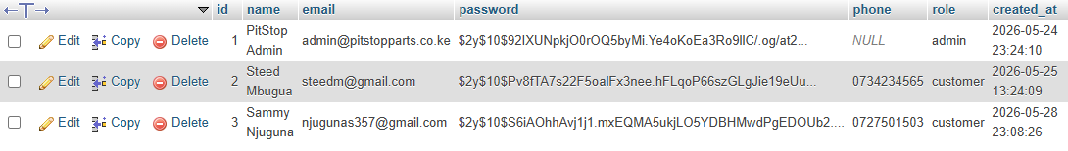
Fig 4: User ‘Steed’ added to database after registration. This proves the full cycle form submitted, PHP processed it, MySQL stored it.
MY WEEK 4 REFLECTIONS;
Technologies used I used PHP for form processing and session management, MySQL for storing registered user records, and the password_hash function for secure credential storage. The mysqli prepared statements were used to prevent SQL injection on all form inputs.
The $_SESSION keeps the user authenticated across the homepage, shop, cart, and admin panel for the duration of their browser session, preventing frequent logins over and over again.

Week 4 screenshots;
Fig 1 – PHP section handling the POST request, demonstrating server-side form data processing.
Fig 2 – HTML form using the POST method to send data to the server.
Fig 3 – Session-based authentication with admin logged in, showing $_SESSION storing user ID and role after password verification.
Fig 4 – User 'Steed' added to the database after registration, confirming the full form-to-database cycle.

WEEK 5: DATABASE COMPONENTS AND CRUD OPERATIONS.
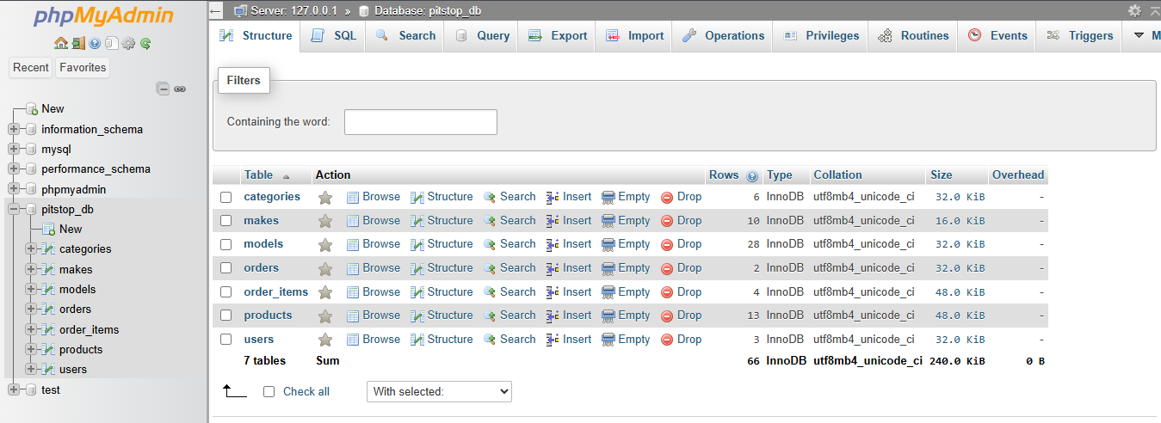
Fig 1: Database created with 7 tables.
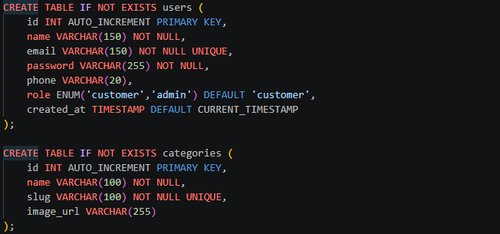
Fig 2: Sample SQL queries to create tables.
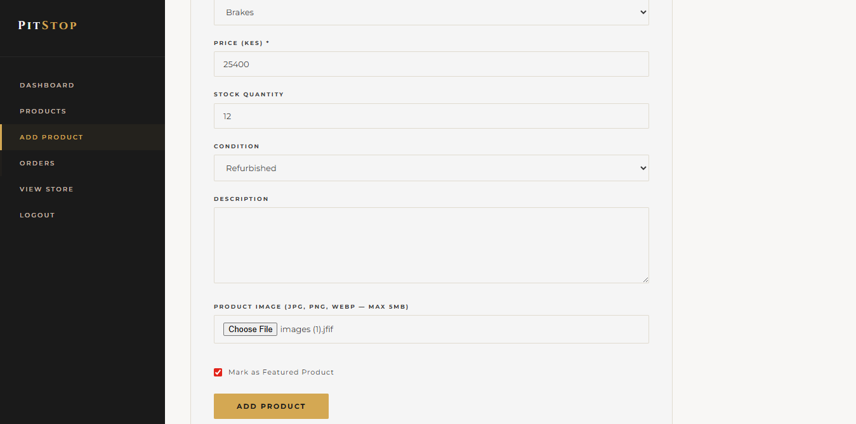
Fig 3: Adding product to shop(create).
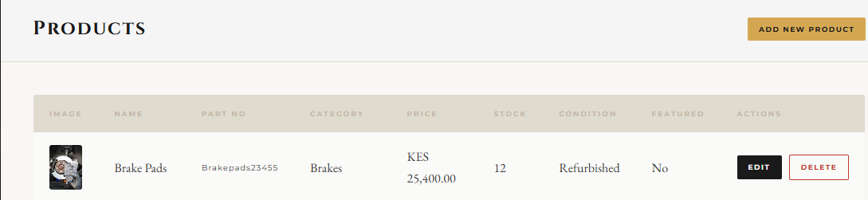
Fig 4: Item ‘brake pads’ added to shop(create+read).
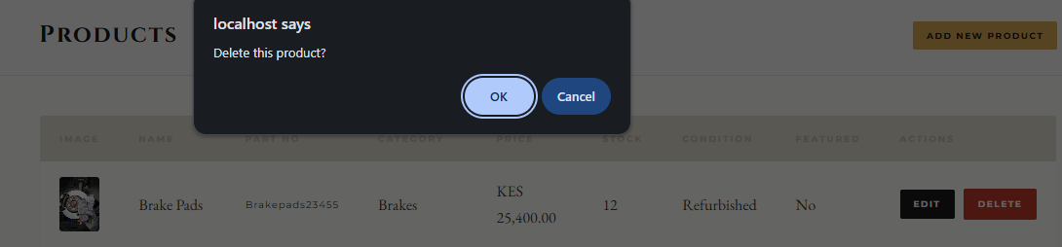
Fig 5: Item ‘brake pads’ deleted.

WEEK 5 LESSONS.
Technologies used I used MySQL for the relational database, phpMyAdmin for visual database management, PHP with mysqli prepared statements for all database queries, and the admin panel as the frontend interface for CRUD operations.
Every e-commerce system is built on CRUD. It allows the admin to list new parts, Read powers the product catalogue customers browse, Update keeps prices and stock levels accurate, and Delete removes discontinued parts from the system.

Week 5 screenshots;
Fig 1 – Database created with 7 tables.
Fig 2 – Sample SQL queries used to create the tables.
Fig 3 – Adding a product to the shop, demonstrating the Create operation.
Fig 4 – Item 'brake pads' successfully added, demonstrating Create and Read.
Fig 5 – Item 'brake pads' deleted, demonstrating the Delete operation.

GITHUB LINK; https://github.com/sammy1-com/pitstop
LIVE HOSTING LINK; https://pitstopparts.up.railway.app

